PRICEOYE LAPTOP MARKET
Exploratory Data Analysis — Findings & Recommendations
Prepared for: Merchandising & Pricing Strategy Team
Prepared by: Data Analytics Team
Date: July 14, 2026
Data Source: priceoye_laptops_version_2.csv (PriceOye catalog scrape, 306 raw listings; 291 analyzed after cleaning)

Executive Summary
This report summarizes the exploratory data analysis (EDA) conducted on PriceOye's laptop catalog (291 listings across 7 brands, after data cleaning). The analysis examines brand assortment, pricing behavior, discounting patterns, and specification trends to inform merchandising, pricing, and promotional strategy.
Key takeaways:
- HP and Lenovo dominate catalog volume (108 and 85 listings respectively — 66% of the catalog combined), while Acer and Infinix are niche players (13 and 6 listings).
- Acer commands the highest average price (PKR 520,384) despite having the fewest listings among major brands, reflecting a gaming/high-performance positioning (Predator, Helios series).
- Apple is the most price-consistent premium brand (mean PKR 425,381 vs. median PKR 420,000 — a narrow spread), while Lenovo and Asus show wide mean-median gaps, indicating a portfolio that spans both budget and flagship tiers.
- Infinix is a pure budget play — the lowest average price (PKR 197,499) and highest average discount (17.0%), consistent with a volume/entry-level strategy.
- The high-value segment (top 10 most expensive listings) is dominated by Lenovo (6 of 10) and Acer (3 of 10) — both driven by gaming/workstation-class configurations (Ultra 9, Core i9, 32–64GB RAM, 1–2TB SSD).
- The entry-level segment (bottom 10 cheapest listings) is dominated by HP (6 of 10), all Core i3-class machines priced between PKR 111,999 and 129,999.
- Core i5, Core i7, and Ultra 7 are the most common processor tiers in the catalog, most frequently paired with 512GB SSD storage — the market's de facto standard configuration.

1. Introduction & Objective
PriceOye is an online electronics marketplace listing laptops from multiple brands. This analysis was commissioned to translate a raw, unstructured product catalog into actionable insight for the merchandising and pricing strategy team. The guiding business questions were defined in the project's problem statement and business-questions documentation, and are answered in turn in Section 3 of this report.
The objective is threefold: (1) quantify brand positioning and price competitiveness within the catalog, (2) identify discounting patterns by brand, and (3) surface specification trends that reflect current market standards, in order to support decisions on brand promotion, price-band coverage, and catalog gaps.

2. Data & Methodology

2.1 Data Source
The dataset originates from a scrape of PriceOye's laptop catalog (priceoye_laptops_version_2.csv), 306 raw listings across 7 brands (Apple, Acer, Asus, Dell, HP, Infinix, Lenovo), with fields covering pricing, discount, brand, processor tier, RAM/storage, and limited customer rating data.

2.2 Cleaning & Preparation
Prior to this analysis, the raw catalog was cleaned and standardized (documented separately in the project's data cleaning plan). Key preparation steps included:
- Brand name normalization (case/spelling inconsistencies merged, e.g., "ASUS"/"Asus" → "Asus").
- Discount field parsed from text ("21% OFF") into a numeric Saving(%) field.
- Processor tier (Core) standardized and back-filled from the product title text where the original field was missing.
- RAM and storage fields parsed out of combined free-text specification strings.
- Products were bucketed into four price bands: <150K, 150K–300K, 300K–500K, and 500K+ (PKR).

2.3 Tools
Analysis was performed in Python using pandas for data manipulation and seaborn/matplotlib for visualization, within a Jupyter notebook (03_eda.ipynb).

2.4 Scope & Limitations
- Customer rating/review data was excluded from this phase of analysis — over 90% of listings have no rating, making rating-based conclusions statistically unreliable at this time.
- All prices are catalog list/discounted prices at the time of the scrape; they represent a single point-in-time snapshot, not a time-series view of pricing trends.
- "Actual Price" is used as the primary price metric for brand comparisons (pre-discount, list price), which controls for temporary promotional variance.

3. Findings

3.1 Brand Market Share
The catalog is heavily weighted toward two brands. HP leads with 108 listings, followed by Lenovo with 85 — together accounting for roughly two-thirds of all catalog listings. Dell (32) and Asus (26) hold a moderate presence, while Apple (21) maintains a smaller, premium-only footprint. Acer (13) and Infinix (6) are the smallest segments, each representing a narrow, purpose-specific niche (gaming-performance and ultra-budget, respectively).
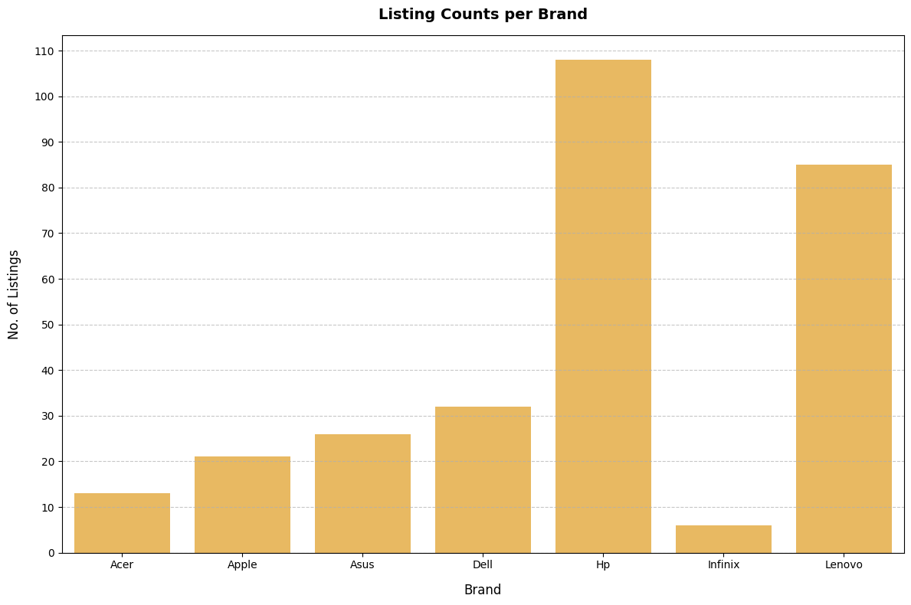
Figure 1. Listing count per brand.

3.2 Price Positioning by Brand
Average and median list price vary substantially by brand, reflecting different market positioning strategies:
Brand | Mean Price (PKR) | Median Price (PKR) | Listings
Acer | 520,384 | 449,999 | 13
Apple | 425,381 | 420,000 | 21
Lenovo | 348,962 | 280,000 | 85
Asus | 330,538 | 280,000 | 26
HP | 276,226 | 257,500 | 108
Dell | 266,125 | 235,000 | 32
Infinix | 197,499 | 164,999 | 6

Acer's high average price, despite the smallest major-brand listing count, is driven by a catalog concentrated in gaming/workstation-class hardware (Predator, Helios series) rather than a broad mainstream range. Apple shows the tightest mean-median gap of any brand, consistent with a narrow, consistently premium product line. Lenovo and Asus show the widest mean-median gaps among mid-tier brands, indicating portfolios that span both budget and flagship configurations — a strategic advantage for reaching multiple customer segments under one brand.
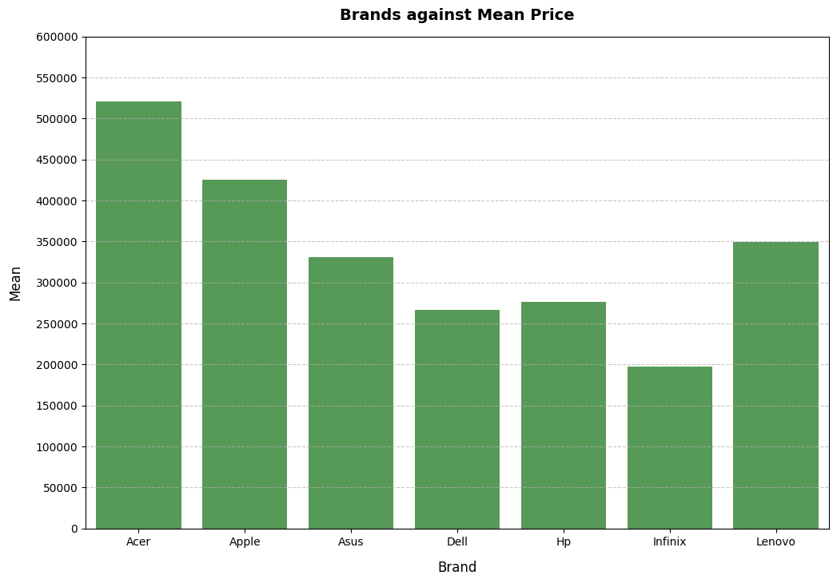
Figure 2. Mean list price by brand (PKR).

3.3 Discounting Behavior by Brand
Average discount percentage also varies meaningfully by brand:
Brand | Average Discount (%)
Infinix | 17.00
Dell | 16.72
HP | 15.67
Asus | 15.62
Lenovo | 13.59
Apple | 10.90
Acer | 9.69

Infinix and Dell discount most aggressively, consistent with volume-driven, price-sensitive positioning. Apple and Acer discount the least — for Apple this reflects typical premium-brand price discipline; for Acer it suggests limited promotional flexibility on its performance-oriented catalog, or lower price elasticity in that segment.
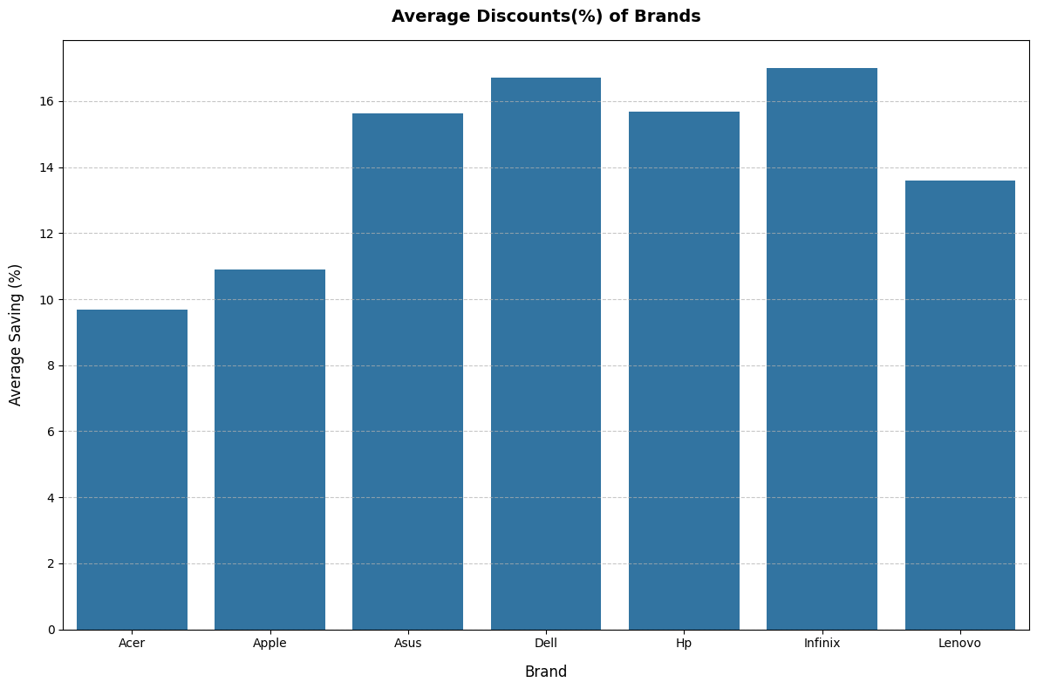
Figure 3. Average discount percentage by brand.

3.4 High-Value vs. Entry-Level Segments
Examining the top and bottom 10 listings by price reveals a clear brand split by segment:
Top 10 most expensive listings (PKR 629,999 – 1,599,900): dominated by Lenovo (6 of 10) and Acer (3 of 10), with Dell appearing once. These listings are exclusively high-performance gaming/workstation configurations — Ultra 9 and Core i9 processors, 32–64GB RAM, and 1–2TB SSD storage (e.g., Lenovo Legion Pro 7, Acer Predator Helios 18).
Bottom 10 cheapest listings (PKR 111,999 – 129,999): dominated by HP (6 of 10), with Lenovo, Infinix, and Dell each appearing once or twice. Every listing in this segment runs an entry-level Core i3 processor, confirming HP's strong footprint in the budget/entry segment.
This bifurcation suggests brand-specific strategic lanes already exist within the catalog: Lenovo and Acer anchor the high-performance ceiling, while HP anchors the value floor — a pattern merchandising can lean into rather than compete against.

3.5 Processor Tier & Storage Configuration Trends
Core i5, Core i7, and Intel Core Ultra 7 are the most frequently listed processor tiers in the catalog. Across nearly all processor tiers, 512GB SSD is the most common storage configuration, indicating it has become the de facto market standard rather than a premium differentiator. Higher-end tiers (Ultra 9, Core i9, Ryzen 9) are more frequently paired with larger storage (1TB+), consistent with their positioning in gaming/workstation-class listings identified in Section 3.4.
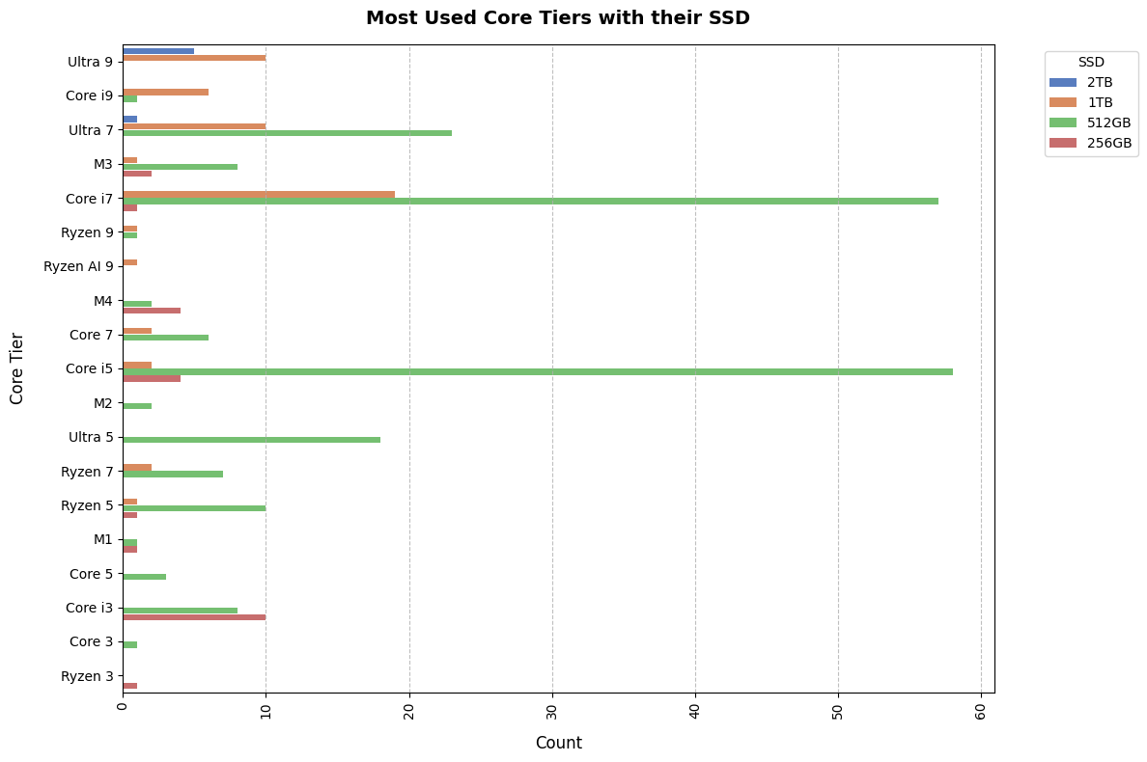
Figure 4. Listing count by processor tier, segmented by SSD capacity.

3.6 Price Band Coverage by Brand
Segmenting the catalog into four price bands (<150K, 150K–300K, 300K–500K, 500K+) shows where each brand concentrates its offering. HP and Lenovo together account for the bulk of listings in the entry and mid-range bands (<150K and 150K–300K), giving them the broadest reach among price-sensitive buyers. The 300K–500K band is more evenly contested, with Asus, Dell, Apple, and Lenovo all present. The 500K+ band is the smallest in volume and is concentrated among Lenovo's Legion series and Acer's Predator series, reinforcing that ultra-premium/gaming positioning is a narrow, brand-specific niche rather than a broad market segment.
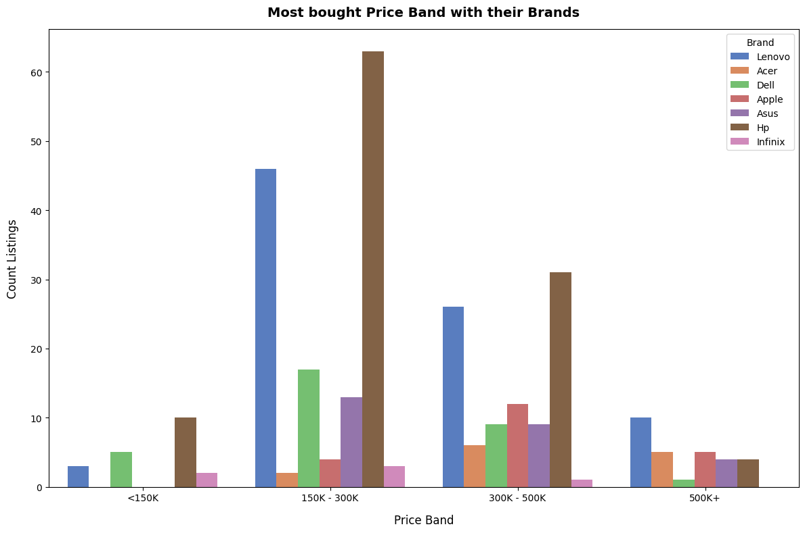
Figure 5. Listing count by price band, segmented by brand.

4. Recommendations
Based on the findings above, the following actions are recommended for the merchandising and pricing strategy team:
- Promote HP and Lenovo as the primary volume/traffic drivers in marketing placements for entry- and mid-range shoppers, given their dominant combined share (67%) of the <300K price bands.
- Position Acer and Lenovo Legion as the go-to recommendation for the high-performance/gaming segment (500K+), where they already hold the strongest combined presence — rather than attempting to build this segment around brands with limited catalog depth there (e.g., Apple, Infinix).
- Reassess Acer's and Apple's discounting strategy. Both currently discount below the catalog average (9.7% and 10.9% respectively); a modest, targeted promotional push on these brands could improve conversion in the premium segment without requiring new catalog investment.
- Treat 512GB SSD as the baseline configuration expectation across future catalog additions and marketing copy, since it is already the market-standard pairing across most processor tiers — differentiate new listings on RAM, processor generation, or storage type (SSD vs. NVMe) rather than storage capacity alone.
- Evaluate expanding Infinix's or a comparable ultra-budget brand's catalog depth (currently only 6 listings) if the entry-level (<150K) segment shows strong conversion, since it is currently under-represented relative to demand signals in the <150K and 150K–300K bands dominated by HP/Lenovo.
- Prioritize collecting customer rating and review data going forward — with over 90% of listings currently unrated, the catalog lacks the social-proof signal needed to support a future rating-driven analysis or recommendation feature.

5. Limitations & Next Steps
- This analysis is a point-in-time snapshot; recommendations should be revisited as pricing and catalog composition change, ideally via a repeatable/automated data pipeline.
- Rating and review coverage is too sparse (< 10% of listings) to support reliable customer-sentiment conclusions at this time.
- Two processor-tier values could not be automatically resolved during cleaning and required manual review; a small number of listings may carry residual data-quality gaps.
- Recommended next steps: (1) incorporate a price-per-spec (e.g., price per GB RAM/storage) value analysis to identify the best-value listings per brand; (2) track price and discount changes over time once repeat scrapes are available; (3) revisit rating-based analysis once review coverage improves.

